Executive Summary
Dify is an open-source agentic AI workflow platform that enables rapid development of LLM-based applications via a visual, low-code interface[1][2]. It supports hundreds of models (OpenAI’s GPT, Mistral, Llama3, etc.) out of the box[3], and includes built-in RAG (retrieval-augmented generation) pipelines for incorporating custom knowledge (documents, PDFs, etc.) into workflows[4][5]. Developers define workflows by connecting nodes (LLM calls, data transformations, loops, conditionals, API calls, etc.) on a canvas, and Dify handles execution and scaling. Critical features include agentic tools (function-calling/ReAct) with 50+ prebuilt integrations (Google Search, DALL·E, etc.), real-time logging and LLMOps monitoring[6], and Backend-as-a-Service APIs for any workflow[7]. Dify can be used via Dify Cloud (hosted SaaS with free trial credits) or self-hosted Community/Enterprise editions[8]. In practice, enterprises have rapidly deployed Dify at scale – for example, Kakaku.com enabled 75% of employees to build nearly 950 AI apps internally within months using Dify Enterprise[9][10].
For developers, Dify offers a rich toolkit: visual workflow nodes, multi-modal input support (text, images), and extensibility through custom code or plugins. For decision-makers, Dify provides enterprise-grade controls (SSO, per-workspace quotas, audit logs, network security) and flexible deployment options. Key decision criteria – cost (free tier vs. paid plans), scalability (Kubernetes/Helm charts, cloud autoscaling), security (role-based access, SSO, Cloud Armor) and maintainability (open-source community, enterprise support) – are addressed by Dify’s architecture and editions. The rest of this report covers an in-depth overview, technical deep dive, implementation examples, operational considerations, a decision-maker checklist, and recommended next steps, with architecture diagrams, tables, and code snippets to illustrate the platform.

Overview
Dify is a production-ready AI orchestration platform for building chatbots, agents and workflows. It is designed to minimize coding via drag-and-drop nodes and templates[2][11]. Key capabilities include:
- Visual Workflow Canvas: Build multi-step applications by connecting nodes (e.g. Start/Input, LLM Call, Chat Answer, Conditional, Loop, Code, HTTP, etc.)[12][5]. Developers and non-developers alike can create complex apps without writing boilerplate code[2].
- Comprehensive Model Support: Out-of-box integration with dozens of LLM providers (OpenAI, Anthropic, Hugging Face, Mistral, Llama3, Gemini, etc.) and any API-compatible model[3]. Providers and keys are configured per workspace, and models can be swapped at runtime.
- RAG/Knowledge Pipelines: Native support for ingesting and querying custom data. Dify lets you build a knowledge base (using vector stores like Qdrant, Weaviate, TiDB, etc.) and incorporates retrieval nodes that augment user queries with domain data[4][13]. For example, a support bot can search company FAQs or manuals to ground its answers.
- Agent Framework: Users can define autonomous agents via LLM function-calling or ReAct patterns. Dify provides 50+ built-in “tools” (e.g. Google Search, DALL·E, WolframAlpha) that agents can invoke, and also supports custom plugin development. This makes it easy to build agents that perform multi-step tasks (e.g. data retrieval + processing)[14][13].
- LLMOps & Observability: Every run is logged. Dify includes dashboards and metrics (message counts, latencies, usage by model) for monitoring performance. Developers can annotate data and track prompt/response history to iteratively improve applications[6]. Integration with third-party observability (e.g. Langfuse) is also supported.
- Backend-as-a-Service API: Any Dify app can be published as a REST API or a single-page web app[7][15]. The platform auto-generates documentation and credentials. For example, after building a “completion” workflow, a developer simply uses the provided API endpoint /v1/completion-messages (with a Bearer token) to get streaming outputs[15][16]. A Python SDK (dify-client) is available to simplify these calls[16][15].
Architecture: A typical Dify deployment consists of a web-based Studio UI, a Flask/Gunicorn backend API, a PostgreSQL database, Redis (for caching and Celery pub-sub), and asynchronous Celery workers for long-running LLM tasks[17][18]. Here is a simplified architecture diagram:
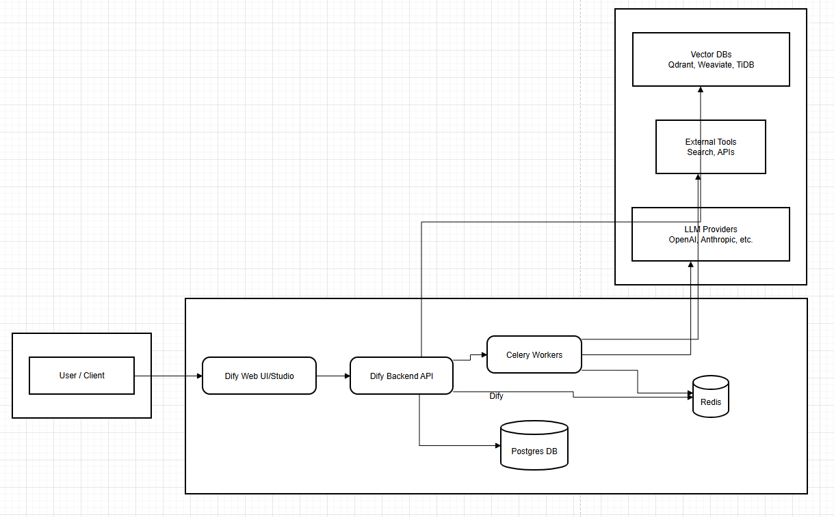

Workflows execute on this stack: the API assigns tasks to Celery workers, which call LLMs or retrieval nodes. Collected results are stored in Postgres/Redis. The system can be scaled horizontally (multiple API workers, Celery processes) and deployed via Docker Compose or Kubernetes (Helm charts are community-supported[19]).
Editions: Dify comes in three flavors[8][20]. The Cloud service (SaaS) offers a free sandbox (200 GPT-4 calls, limited storage) and paid tiers (Professional, Team) per workspace[20][21]. The Community Edition is open-source and self-hosted (free), typically creating a single workspace on install[22]. The Enterprise Edition (custom license) adds multi-workspace support, SAML/SSO (Azure AD etc.), advanced security controls and priority support[8][23]. A decision tree for choosing a deployment model is shown later in Decision-Maker Checklist.

Technical Deep-Dive

Key Concepts & Execution Model
Dify’s core is the workflow graph. Apps (called “workflows” or “chatflows”) are built by connecting nodes. Key concepts include:
- Start and User Input: Every workflow begins with a Start node which can collect user inputs, file uploads, or initial parameters. This feeds into downstream nodes.
- Nodes: Each node encapsulates a function. Common node categories include:
- LLM/Chat Nodes: Invoke LLM completion or chat APIs with configured prompts/templates.
- Answer/Output Nodes: Collect and return final answers (e.g. single-turn or streaming outputs).
- Knowledge Retrieval: Queries the workspace’s knowledge base using semantic search. Returns relevant text chunks.
- Agent/Tools: Manages agentic loops, optionally invoking external tool nodes.
- Control Flow: If/Else, Loop (Iteration) and List nodes enable branching and batching. For example, the Iteration node processes list inputs in sequence[12] – useful for splitting a long document into chunks and translating each piece to avoid token limits[12].
- Integration: HTTP Request, Email, Database or File nodes to connect external services.
- Utilities: Template and Code nodes allow custom data transformations (Jinja templates or inline Python/JavaScript). Parameter Extraction can parse API results into workflow variables.
- Variables & State: Dify maintains two types of variables – session variables (persist across a chat session) and temporary loop variables (reset each iteration)[24]. In a multi-turn chatflow, session variables let the bot remember info. Loop variables, on the other hand, can accumulate knowledge across iterations (the deep-research workflow demonstrates how a loop node tracks “knowledge_gaps” and “visited_urls” over loops)[24]. This is crucial for agentic workflows that loop until a goal is satisfied.
- Triggers & Concurrency: Workflows can be triggered manually, via API calls, or by schedules/webhooks. Cron-like scheduling is supported (see Cron reference). Dify can run workflows in parallel or serially depending on configuration, but careful variable scoping is needed to avoid race conditions. Each workflow run is isolated unless using loop variables intentionally.
- Meta-Language (DSL): The underlying workflow is represented as a JSON-like DSL that specifies nodes, connections, and settings. This enables versioning and API deployment. (The user-facing “drag-and-drop” editor simply generates this DSL.)

Integration and Extensibility
Dify is built to be extensible:
- Model Plugins: You can add custom LLM providers by defining API keys or even building your own plugin connector. There’s a UI for configuring Model Providers (e.g. OpenAI, Azure OpenAI, Hugging Face, local Anthropic, etc.) that are then available workspace-wide[25].
- Custom Code: The Code Node lets you run arbitrary Python or JavaScript inline, useful for specialized logic or data processing beyond built-in nodes[26] (e.g., calling DuckDB, Pandas, etc.). Dify’s Docker images include common libraries, and the docs show how to add extras.
- Plugins & Tools: Dify Marketplace offers plugins (e.g. web scrapers, API connectors). The platform itself supports 50+ integrated tools for agents. Developers can also create MCP (multi-channel) plugins to publish apps (e.g. chatbots) to channels or custom UIs.
- APIs: Critically, every Dify app can be exposed via API. The platform provides Publish → API settings where you generate keys. For example, a text-generation workflow can be invoked with a POST to /v1/completion-messages (with your inputs and API key)[15]. Similarly, chatflows expose /v1/chat-messages with conversation_id for multi-turn chats[27]. Complete API docs and code examples (cURL, Python) are auto-generated per app.

Security and Multi-Tenancy
Dify’s “workspace” concept provides strong isolation[28]. Each workspace contains its own apps, models, knowledge bases, users, and billing. Within a workspace, granular roles (Owner, Admin, Editor, Member, etc.) govern what users can do[29]. For enterprise use:
- Single Sign-On (SSO): Enterprise Edition supports SSO via SAML/OAuth (e.g. Azure AD). Kakaku.com, for instance, integrated Dify with Azure AD so employee access and deprovisioning happen automatically[30].
- Network Security: Dify Cloud can use network policies (e.g. Google Cloud Armor) to restrict app access. The Kakaku case disabled anonymous sharing and enforced rules at the network edge[31].
- Auditing: Activity logs (who ran which app when) are maintained for compliance.
- Data Residency: Community Edition can be deployed in any environment (on-prem, private cloud) to meet data residency requirements.

Implementation Examples
Below are representative examples and code snippets illustrating how to use Dify.
Docker Compose Deployment: The simplest self-hosted setup is via Docker Compose. After cloning the repo, you can run:
cd dify/docker
cp .env.example .env
docker compose up -d
This spins up all services (API, DB, Redis, etc.). Then point your browser to http://localhost/install to initialize the admin account and workspace[32].
Calling Dify via API (cURL/Python): Suppose you built a “greeting” workflow in Dify Studio that returns a text answer. Dify will give you an endpoint like https://api.dify.ai/v1/completion-messages. An example cURL call:
curl --location --request POST 'https://api.dify.ai/v1/completion-messages' \
--header 'Authorization: Bearer YOUR_SECRET_KEY' \
--header 'Content-Type: application/json' \
--data-raw '{
"inputs": {"text": "Hello, how are you?"},
"response_mode": "blocking",
"user": "user123"
}'
[15]. In Python, using requests:
import requests, json
url = "https://api.dify.ai/v1/completion-messages"
headers = {'Authorization': 'Bearer YOUR_SECRET_KEY','Content-Type':'application/json'}
data = {"inputs": {"text": "Hello!"}, "response_mode": "streaming", "user": "user123"}
res = requests.post(url, headers=headers, data=json.dumps(data))
print(res.text)
[15]. The response will stream back the LLM’s answer. For chatflows, use /v1/chat-messages and manage conversation_id to maintain context[33][34].
Python SDK Example: Dify provides a dify-client package on PyPI[35]. After pip install dify-client, you can do:
from dify_client import CompletionClient
client = CompletionClient("YOUR_API_KEY")
res = client.create_completion_message(
inputs={"query": "Summarize Dify features"},
response_mode="blocking", user="user123")
res.raise_for_status()
print(res.json().get("answer"))
This uses the same underlying API, but with a friendly wrapper[36]. Similarly, there is ChatClient for conversation, and a generic DifyClient for file uploads.
Workflow Example – Deep Research Loop: As a practical example, consider a “deep research” workflow that iteratively expands on queries (a Dify tutorial from 2025). It starts with a Start node where you input the initial research question. Subsequent nodes perform steps like querying an answer engine and extracting “knowledge gaps.” A Loop node then iterates: each cycle it queries again and accumulates context until a stopping condition. In the UI below, the Start node is being configured with input parameters (e.g. “research topic”)[37]:
[37]<br> Figure: Configuring the Start node in Dify Studio (entering research topic and settings).
Inside the workflow, a Loop node powers the research engine: it maintains variables like knowledge_gaps and visited_urls across iterations, and updates a knowledge_graph structure[24]. In each loop, an LLM node is fed the accumulated context and continues the chain of inquiry. Below is an example of the Loop node in action:
[24]<br> Figure: A Loop node in Dify capturing variables across iterations (source: Dify blog[24]).
This loop continues until no new gaps remain, demonstrating how Dify can orchestrate a multi-turn, stateful AI process.
Publishing a Web App: Beyond raw APIs, you can publish workflows as user-facing chatbots or web widgets. In Dify Studio under Publish → Web App, a single-page application is generated with a public URL (or embed code). For example, after publishing, an HTTP client can GET the embed link or include it in an <iframe>. Access controls (public/shareable link or restricted) are configurable.

Operational Considerations
Scaling & Deployment: Dify can run on a single machine (min 2CPU, 4GB RAM recommended[38]) or scale to Kubernetes. Community Helm charts and Terraform scripts (AWS, Azure, GCP) are available[19][39]. In high-traffic scenarios, run multiple Gunicorn workers and Celery instances; scale PostgreSQL with replica or external DB; use a robust Redis cluster or Sentinel for high availability[17][18]. Vector search can be scaled by deploying an external Qdrant/Weaviate cluster for knowledge bases. In one large deployment, Dify integrated the TiDB Vector engine and Qdrant to accelerate retrieval at scale[40][13].
Security & Compliance: For sensitive deployments, use TLS for all endpoints (the Helm chart supports certs). Leverage the Workspace Roles model[29] to restrict who can create or publish apps. In Enterprise usage, SSO ensures centralized user management[41]. Disable any public-sharing if needed and enforce network rules via firewall or CDN (as Kakaku did with Google Cloud Armor)[31]. Regularly rotate Dify encryption keys (SECRET_KEY, JWT secrets) per the Environment Configuration docs.
Monitoring & Logging: Dify logs all message and system events. You should integrate these logs with your observability stack (the docs show importing a Grafana dashboard that queries Dify’s Postgres metrics[42]). Cloud customers get built-in dashboards. Track costs by mapping Dify usage (API calls, trigger events) to billing. In multi-workspace Enterprise, each workspace can have its own subscription/budget.
Maintenance & Updates: Community Edition is free but self-service; you’ll need to update the Docker images or chart when new versions release (GitHub stars ~130k indicates active community[43]). Enterprise customers get professional support and patch releases. Back up the Postgres database regularly (it holds all app definitions and user data). Self-hosters should also back up the vector indexes or re-ingest documents as needed.
Security Reviews: Dify’s license (Apache2-derived[44]) allows self-hosting without vendor lock-in. Run security scans against Dify containers; at least one user reported scaling Dify’s DB pool for high concurrency[45]. Use a web application firewall (WAF) if exposing Dify Cloud to the internet.

Decision-Maker Checklist
For executives and architects evaluating Dify, key questions and criteria include:
- Deployment Model:
- Cloud vs Self-Host vs Enterprise? Dify Cloud (SaaS) offers convenience and included GPT-4 credits[8]. Community Edition is free to self-host (max 1 workspace). Enterprise Edition adds multi-workspace isolation, SSO, and premium support[8][46].
- Cost: Cloud pricing starts at \$59–\$159 per workspace/month (Pro/Team tiers)[20][21]; self-host has no software license fee (but you manage infra).
- Vendor Support: Enterprise licenses include SLAs and direct support. Community Edition relies on community and documentation.
- Scalability:
- Concurrency: Can run on Kubernetes with autoscaling. Case studies show Dify handling thousands of internal users (Kakaku had 75% employee adoption)[47].
- Data Throughput: If using heavy RAG, plan for an external vector DB. Dify integrates natively with solutions like Qdrant or TiDB Vector[13][40] to handle large-scale searches.
- Security/Compliance:
- Access Control: Multi-role workspaces ensure isolation. Verify Dify meets your security standards (e.g. is open-source audited?).
- Data Sensitivity: Sensitive data stays in your infrastructure on Community/Enterprise. Cloud customers should confirm data handling policies. Dify’s Cloud (“sandbox”) limits data storage in free tier (e.g. 5GB or 50MB depending on plan[20]).
- Governance: Enterprise Edition supports Azure AD SSO, and allows each team a separate “workspace” with its own admin, budgets and audits[48][29]. For regulated industries, this is a plus.
- Feature Fit:
- Agentic Needs: If you need autonomous multi-step bots or complex RAG, Dify’s built-in agents and tools could speed development vs building from scratch or using lower-level frameworks.
- Developer Skillset: Dify shines if you want a no-code/low-code approach. But for teams with heavy coding experience, compare against frameworks like LangChain (though Dify boasts more built-in features and enterprise polish[49]). Table below compares Dify to a typical LLMP dev framework:
Criterion | Dify Platform | DIY Frameworks (e.g. LangChain, Airflow)
Ease of Use | Visual builder, minimal coding[2] | Code-centric; steep learning curve
Multi-LLM Support | Dozens of providers pre-integrated[3] | Supported, but manual setup needed
RAG Pipeline | Built-in docs ingestion, vector search nodes[5] | Must build pipeline manually (e.g. ingest & query)
Agent Tools | 50+ prebuilt tools + plugin system[14] | Must write/integrate tools individually
Deployment | SaaS or Docker/K8s with one-click scripts[32] | Custom deployment scripts; more ops work
Monitoring | Built-in LLMOps dashboard and logs[6] | Requires external monitoring setup
Cost | SaaS subscription or free self-host | Free code, but dev/ops effort cost
Support/License | Enterprise edition + support; open-source license[44] | Community support; license depends on each library
- Maintainability:
- Upgrades: Cloud users get automatic updates. Self-hosters must pull new Docker images or Helm charts.
- Vendor Lock-in: Dify is open-source (custom license), and workflows export to JSON DSL. However, custom code in nodes could limit portability.
- Community: The project is active (GitHub ~130k stars[43]) and has corporate backing (LangGenius) with a dedicated R&D team[50][26].
Decision Tree: The diagram below helps decide which edition fits your needs:

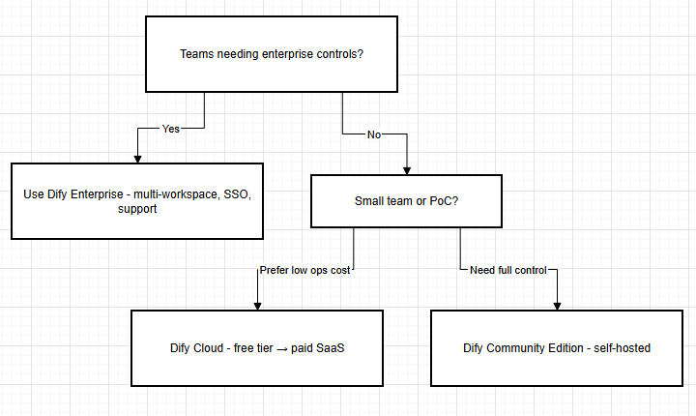Risks and Mitigations
- Vendor/Beta Risk: While Dify is production-grade, it’s younger than some incumbents. Mitigation: Start with less critical apps, validate scalability, contribute to the community or hire experienced consultants.
- Operational Complexity: Self-hosting large-scale Dify (especially RAG heavy apps) requires solid DevOps. Mitigation: Use managed DB/vector services and auto-scaling clusters. Consider Dify Cloud or AWS Marketplace AMIs for easier infra.
- Cost Overrun: On Cloud, LLM API usage (like GPT-4 calls) can be expensive. Mitigation: Monitor usage closely, use on-prem models (open-source) when possible, cap outputs (Dify allows controlling tokens).
- Security Gaps: Bugs or misconfiguration could leak data. Mitigation: Keep Dify updated, enforce HTTPS, disable anonymous sharing, use network policy. Regularly review logs and workspace permissions[29].
- Skills Gap: Although low-code, teams still need to understand LLM behaviors. Mitigation: Provide training in prompt engineering and Dify concepts (e.g. how loop variables work[24]).

Recommended Next Steps
- Pilot Deployment: Spin up a sandbox (either Dify Cloud trial or self-hosted Community edition with Docker Compose) and build a simple workflow (e.g. a support Q&A bot with a small knowledge base) to evaluate ergonomics and performance[15][4].
- Compare Alternatives: Briefly prototype a similar app in a code-based framework (e.g. LangChain or an internal microservice). Evaluate developer velocity and ease of deployment[49].
- Cost Analysis: Estimate usage (requests/minute, token counts) of your intended apps, and use Dify’s pricing tiers[20][21] to forecast cloud subscription needs.
- Security Review: For enterprise use, plan integration with your SSO/AD. Test a dummy integration flow. Verify Dify’s support for your compliance requirements (e.g. data retention policies).
- Scale Testing: If possible, load-test the Dify deployment (e.g. simulate many concurrent chat sessions) and monitor throughput. Adjust Gunicorn/Celery settings as needed[17][18].
- Training & Knowledge Transfer: Ensure your team is familiar with Dify’s node paradigm. Recommend consulting Dify tutorials and the community forum for best practices.
Dify’s rich feature set and growing ecosystem make it a powerful option for organizations seeking to deploy AI solutions rapidly. When aligned with your technical roadmap and governance needs, it can significantly accelerate AI application delivery, as evidenced by real-world adopters[47][49].

